1. The json database:
   1. A REST API with JSON server was created to save time on JAVA RESTful service or REST API via node.js using Mondo DB and Express.
   2. JSON server is a simple project that helps setup a REST API with CRUD ops.
   3. Installation
      1. $ npm install –g json-server // -g option for installing it globally.
   4. JSON file is available as *db.json.*
   5. Running the server:
      1. $ json-server –watch db.json
   6. Open URL as <http://localhost:3000/pokemon>
   7. 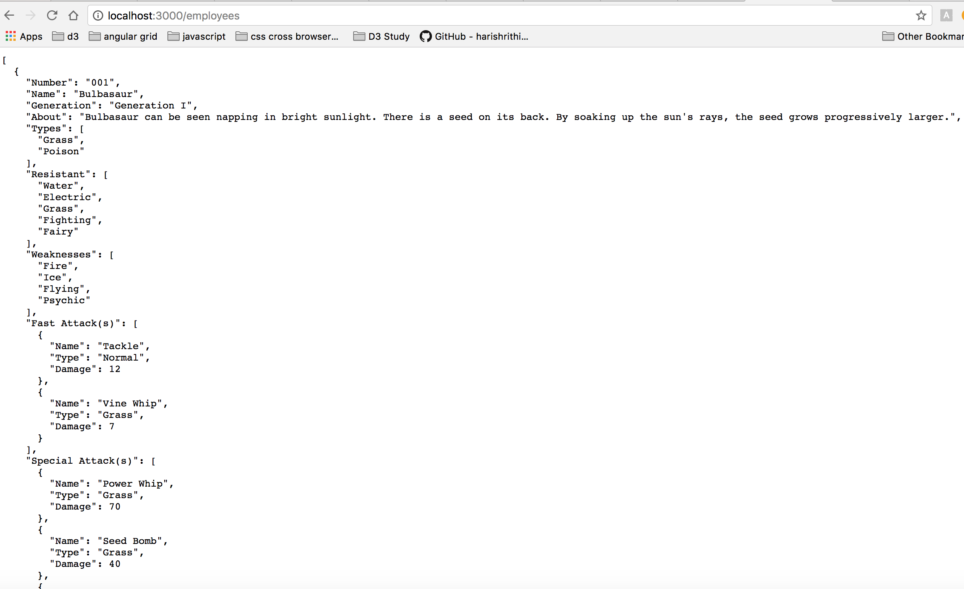
2. The Angular Single Page App with Webpack:
   1. Made a new dir as pokemon
   2. Create a package.json
   3. Installed dependencies
      1. Angular
      2. Angular-ui-router
      3. Webpack
   4. Created webpack config js
   5. Installed babel and babel-loader for using features of ES2015 (ES5).
   6. Designed angular module inside app as app.module.js
   7. Created index.html and added ng-directive.
   8. Needed a server and a live reload so installed lite-server.
      1. Npm install ---save-dev lite-server.
   9. Updated package.json for these changes:
      1. “Start”: “lite-server”
   10. Created routes as app.routes.js
   11. Special mention for Package.json for concurrently running webpack and lite-server.
   12. Created pokemons component. pokemons routes and pokemons html

